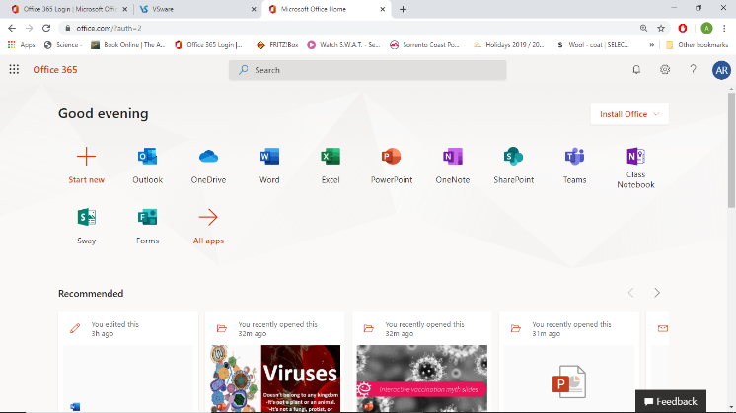

## Logon on a Phone

1. Go to you Appstore and download **Outlook by Microsoft**
2. Then logon with your **username** and **password** (note: your email is not case sensitive (upper or lower case don’t matter; however, your password absolutely **is** case sensitive and needs to be input accurately) If you do not have a password or logon please contact me at
3. Then go back to the Appstore and download **Onedrive** and **Onenote** and log into both of these with the same password. As above you will now have access to file (OneDrive) and your class notebooks (OneNote)

## Logon on a Computer

1. You need to go to <https://www.office.com/>
2. Then logon with your **username** and **password** (note: your email is not case sensitive (upper or lower case don’t matter; however, your password absolutely **is** case sensitive and needs to be input accurately) If you do not have a password or logon please contact me at [aine.rourke@stkevins.cdetb.ie](mailto:aine.rourke@stkevins.cdetb.ie) and I will email it on.
3. You will then see apps to the above
4. **Email** is in **Outlook.** Staff will email you when work is put up
5. Storage of files is in **Onedrive**
6. Class notes, homework, exams and other information from teachers will be emailed or posted in **OneNote** through a Class Notebook. See the back for further information on this.

Class Notebook

File Storage

Email

Microsoft 365 for St Kevins



**Shared Work**

**Individual pages with work**

**Students own notes and homework**

## Using Class Notebook

1. If you are on a **phone/tablet** you go to your **OneNote** app.
2. You should see a list of classes you are joined to, not every teacher has a Class Notebook but some will be here.
3. If you are on a **computer** then logon to <https://www.office.com/>
4. You will see the options on the previous page and you should choose Onenote
5. Once in Onenote you will see the below and you should click on Class Notebooks

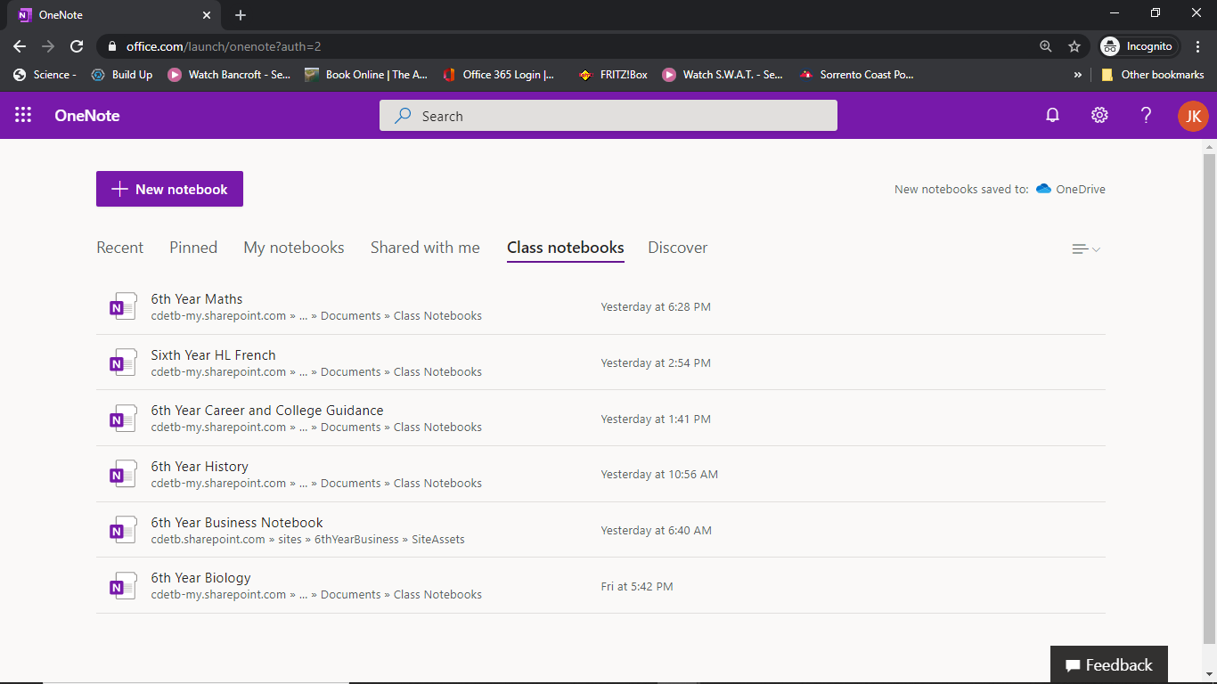

1. Then select the class Notebook you want to see

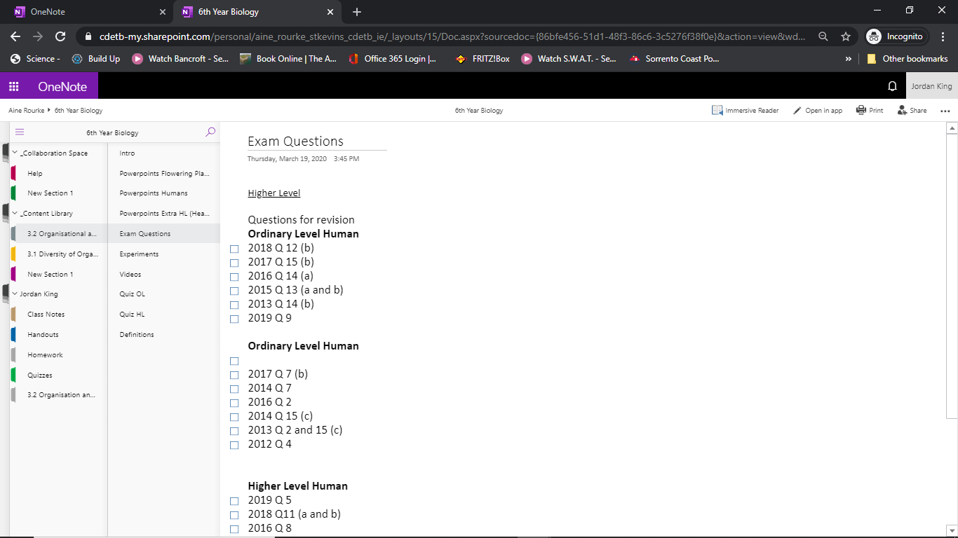

1. The content Space will allow you to see any notes shared by teacher or information.
2. The homework folder under each student’s name is where homework should be submitted for correcting to teacher if they are using this system (instructions on next page)

k

## Help

If you are having any issues accessing information please remember to be **specific** with your problem, are you in the app, is your password not working etc

Also please try googling the issue before contacting staff. Often **Microsoft** have excellent information online and can guide you through issues better than a person over email

Failing that feel free to contact me at [aine.rourke@stkevins.cdetb.ie](mailto:aine.rourke@stkevins.cdetb.ie) and I’ll do my best to fix the issue

## Submit work

1. Once you have completed you work you then need to submit it to the teacher.
2. Follow the steps on the previous page and go to the correct **Class Notebook.**
3. You then go to your own Name and click the file labelled **Homework**

* 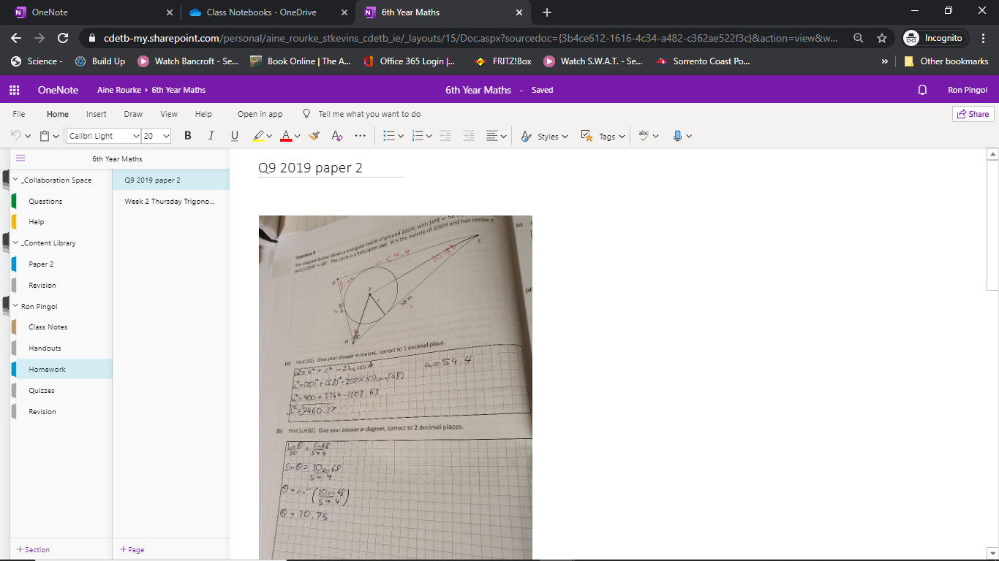

1. You can then copy a picture or the work/type the work/insert a file here
2. You can add a page in homework by right clicking in the second column and clicking new page
3. Name it something sensible, maybe the day or date or the question you are answering
4. The teacher can now correct this work.
5. I would recommend using the **OneNote** app on your phone if you are jut taking a photo, it allows you too directly capture the picture by jut going to the page and hitting insert. Its very easy to use.

v

v

v