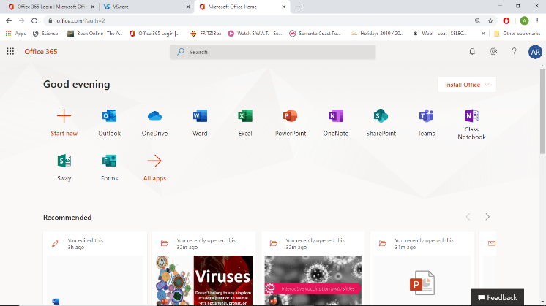

Logon
- You need to go to https://www.office.com/

- Then logon with your username and password (note: your email is not case sensitive (upper or lower case don’t matter; however, your password absolutely is case sensitive and needs to be input accurately so mind the capitals)

- You will then see apps to the right

- Email is in Outlook – if you want email on
your phone you need to download the
corresponding app.

- File storage is in Onedrive (it is essential you
have a sensible filing system) Again this app
can be downloaded.

- Teams is a great app for your homework and notes.
Note: Teams generally works better with Internet Explorer (it’s designed for this) so if you have an issue just double check that is the browser your using. If not, switch to using explorer.

Microsoft Teams

Once you have logged on you should have an email from me inviting you to join a Team for all your Subjects.

This is where homework will be set and corrected!!

